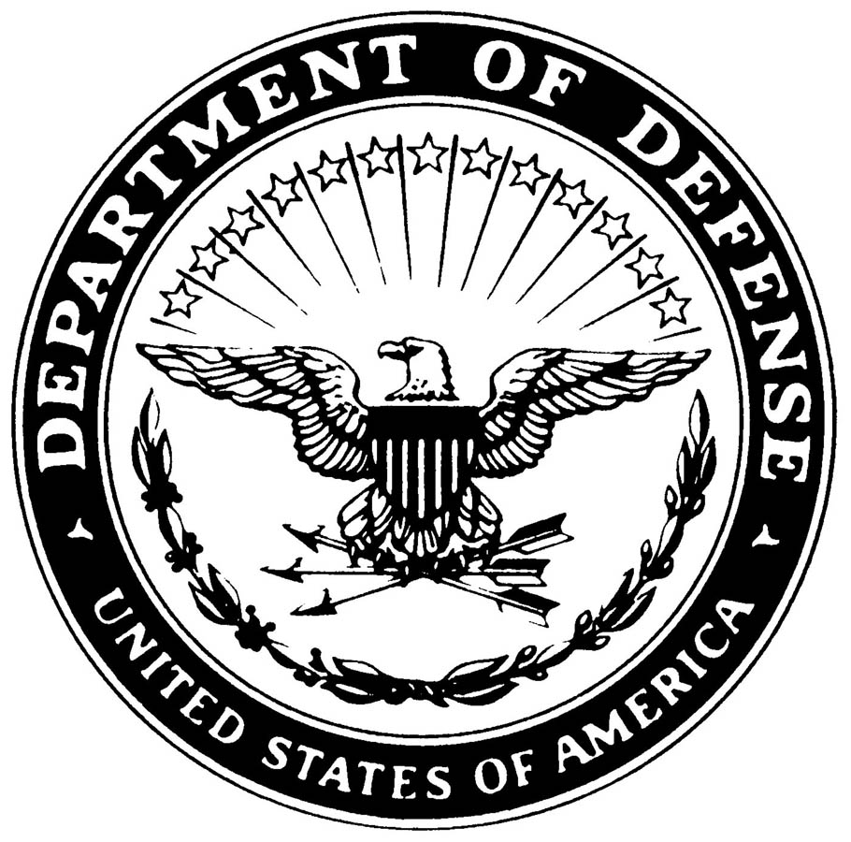**UNITED STATES MARINE CORPS**

MARINE AIR GROUND TASK FORCE TRAINING COMMAND

MARINE CORPS AIR GROUND COMBAT CENTER

BOX 788100

TWENTYNINE PALMS, CALIFORNIA 92278-8100

CCO XXXX.X

ORG CODE

COMBAT CENTER ORDER XXXX.X

From: Commanding General

To: Distribution List

Subj: FIVE-PARAGRAPH ORDER FORMAT

Ref: (a) CMC Policy Memo 3-11 of 25 June 2000

(b) MCO 5215.1K

Encl (1) If any

1. Situation. Per reference (a), policy-based directives that impact the commanders in the field shall be written as Marine Corps directives in a 5-paragraph order format. This example provides the proper format. Reference (b) provides detailed information on formatting questions.

2. Cancellation. MCO 5215.1H. (List cancelled directives, if any.)

3. Mission. The mission statement provides the reason why the order was written. It answers the who, what, where, when, and why questions regarding this Order.

4. Execution

a. Commander’s Intent and Concept of Operations

(1) Commander’s Intent

(a) The commander’s intent is the commander’s personal expression of the purpose of the order.

(b) It must be clear, concise, and easily understood.

(c) It may also include how the commander envisions achieving a decision, as well as the end statement or conditions that accomplish the purpose.

(2) Concept of Operations. The concept of operations is an overview of how the commander plans to accomplish the mission. It further answers the who, what, where, when, and why questions.

DISTRIBUTION STATEMENT A: Approved for public release; distribution is unlimited.

b. Subordinate Element Missions

(1) Comply with the intent of the reference and the content of this Order.

(2) Directive sponsors are responsible for ensuring that their directives are in the correct format.

c. Coordinating Instructions. Submit all recommendations concerning this Order or Marine Corps directives in general to CMC (ARDB) via the appropriate chain of command.

5. Administration and Logistics. Distribution statement A directives issued by the Commanding General are distributed via email upon request and can be viewed at http://www.29palms.usmc.mil/dirs/manpower/adj/ccotoc.asp.

5. Command and Signal

a. Command. This Order is applicable to all special staff, directorates, and activities located aboard the Combat Center.

b. Signal. This Order is effective the date signed.

I. M. MARINE